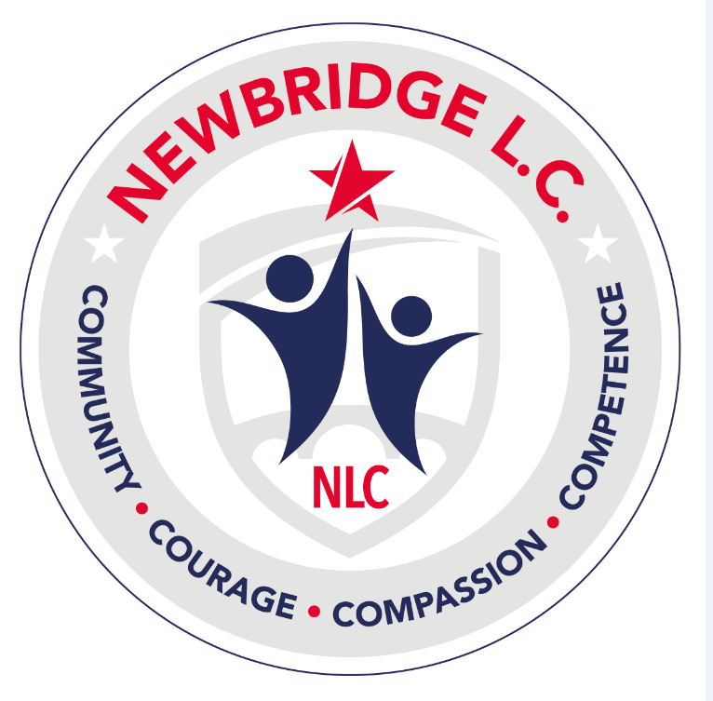
Accessibility Statement - Newbridge Learning Community

Newbridge Learning Community is committed to making its website accessible, in accordance with the Public Sector Bodies (Websites and Mobile Applications) (No. 2) Accessibility Regulations 2018.
This accessibility statement applies to the Newbridge Learning Community website (https://[insert-domain-here]).
This website is run by Newbridge Learning Community. We want as many people as possible to be able to use this website. For example, that means you should be able to:
- Change colours, contrast levels and fonts using browser or device settings
- Zoom in up to 400% without the text spilling off the screen
- Navigate most of the website using a keyboard or speech recognition software
- Listen to most of the website using a screen reader (including the most recent versions of JAWS, NVDA and VoiceOver)
We’ve also made the website text as simple as possible to understand.
How accessible this website is
We know some parts of this website are not fully accessible:
- You cannot modify the line height or spacing of text
- Some older PDF documents are not fully accessible to screen reader software
- Live video streams do not have captions
- You cannot skip to the main content when using a screen reader
- There’s a limit to how far you can magnify the map on our ‘contact us’ page

Feedback and contact information
If you find any problems not listed on this page or think we’re not meeting accessibility requirements, contact:
Accessibility Lead: Ashley Martindale (SBM)
Email: bman@admin.newbridge.wigan.sch.uk
Phone: 01942 369770
Address: Newbridge Learning Community, Moss Lane, Platt Bridge, WIGAN WN2 3TL

If you need information on this website in a different format like accessible PDF, large print, easy read, audio recording or braille, please contact us using the details above.
We’ll consider your request and get back to you in 5 working days.

Enforcement procedure
The Equality and Human Rights Commission (EHRC) is responsible for enforcing the accessibility regulations. If you’re not happy with how we respond to your complaint, you can contact the Equality Advisory and Support Service (EASS).

Compliance status
This website is partially compliant with the Web Content Accessibility Guidelines (WCAG) version 2.2 AA standard, due to the non-compliances listed below.

Non-accessible content
(a) Non-compliance with the accessibility regulations
Some images do not have a text alternative, which fails WCAG 2.2 success criterion 1.1.1 (Non-text Content). We plan to add text alternatives for all images by [insert date].
Older PDFs may not be fully accessible. We aim to replace or update key documents by [insert date].
(b) Disproportionate burden
- No ‘skip to main content’ option
- Device orientation changes may reduce usability
- Increasing text size may cause overlapping content
We consider fixing these issues at this time to be a disproportionate burden but will review this at the next supplier contract renewal (expected [insert timeframe]).
(c) Content not within scope
PDFs published before 23 September 2018 are exempt unless essential. Any new documents we publish will meet accessibility standards.

Live video streams are exempt from requiring captions.
Preparation of this accessibility statement
This statement was prepared on [insert date]. It was last reviewed on [insert date].

This website was last tested 23/02/2026 against WCAG 2.2 AA.
The test was carried out by an internal team.

